CAPSTONE PROJECT-3
Python
Finance Tracker

DONE BY:
KIRUTHIK. A

CONTENTS

TABLE OF THE CONTENTS
CHAPTER | TITLE | PAGE NO.
1 | INTRODUCTION | 1
 | 1.1 OVERVIEW OF THE PROJECT | 1
 | 1.2 OBJECTIVES OF THE PROJECT | 1
 | 1.3 ORGANIZATION PROFILE | 2
2 | SYSTEM ANALYSIS | 3
 | 2.1.METHODALOGY | 3
 | 2.2.CONCEPTS USED | 3
3 | SYSTEM DEVELOPMENT | 4
 | 3.1 BUSINESS REQUIREMENT | 4
 | 3.2 ADVANTAGES OF THE SYSYTEM | 14
 | 3.3. SUMMARY | 15
 | 3.4. CONCLUSION | 16

1.INTRODUCTION

1.1.OVERVIEW OF THE PROJECT

This Python project focuses on building a Personal Finance Tracker that helps users analyze, manage, and calculate their monthly spending. The program includes modules for expense calculation, spending status analysis, data processing, and financial reporting.
It demonstrates the practical use of Python for solving real-life financial problems..

1.2.OBJECTIVE OF THE PROJECT

• Track various monthly expenses
• Calculate total expenses using Python functions
• Categorize users into spending categories
• Build a user-friendly Python program
• Provide a clear financial summary
• Improve user financial awareness

1.3.ORGANAISATION PROFILE

The NIIT Group is a leading digital talent development organization and a premier provider of managed training services, dedicated to building skilled human capital and enhancing workforce talent globally. Established in 1981 to help the nascent IT industry overcome its human resource challenges, the NIIT Group ranks among the world’s leading training organizations due to its vast and comprehensive array of talent development programs. With a footprint in over 10 countries, NIIT Group delivers learning interventions that create superior outcomes. The group comprises NIIT Limited (NIIT) and NIIT Learning Systems Limited (NIIT MTS).
NIIT’s Corporate Learning business has been transferred to NIIT MTS via a composite scheme of arrangement in May 2023. The reorganization helps NIIT create a sharper focus on its Skills & Careers Business which delivers a diverse range of learning and talent development programs to thousands of early careers and working professionals to accelerate career success across futuristic domains including technology and banking.

II.SYSTEM ANALYSIS

Methodology

Input Collection

User enters income and multiple expense values

Processing

Program calculates total expenses using function

3.Status Classification

Saving, Balanced, or Overspending

4.Reporting

Clear structured summary is printed

Concepts Used

- Variables & Data Types
- Lists, Dictionaries, Tuples, Sets
• Loops (for/while)
- Conditional statements
- Functions
- File handling
.

S.NO | BUSINESS REQUIREMENT | QUERY
1 | Enter daily expenses under categories: food, rent, travel, shopping, bills, others  Store them in a dictionary with category as key and amount as value  Print the total daily expense | 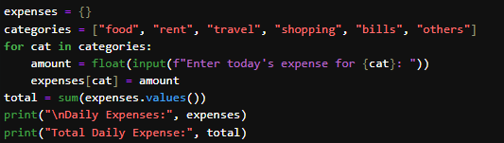
 | OUTPUT | 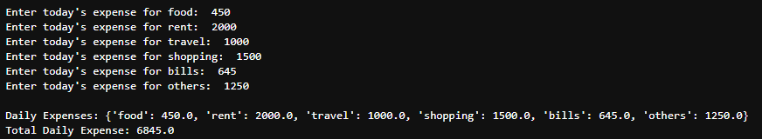
 | INTERPRETATION | This program takes daily expenses for six categories (food, rent, travel, shopping, bills, others) using a loop.  It stores them inside a dictionary, where the category is the key and the amount is the value.  Finally, it sums all values using sum() to get the total daily expense.

S.NO | BUSINESS REQUIREMENT | QUERY
2. | Monthly Expense Analyzer  Create a Python function that accepts a list of daily expenses for 30 days and returns:  Total monthly expense  Average daily expense  Maximum spending day  Minimum spending day | 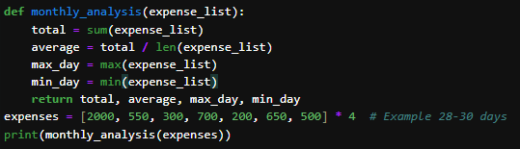
 | OUTPUT
 | INTERPRETATION | This task defines a function monthly_analysis() that takes a list of daily expenses for 30 days.

S.NO | BUSINESS REQUIREMENT | QUERY
3 | Conditional Savings Calculator  Write a program using if–else that:  Takes monthly income and monthly expense as input  Calculates savings = income − expense  Prints:  “Excellent Saver” if savings ≥ 40% of income  “Moderate Saver” if savings ≥ 20%  “Poor Saver” otherwise | 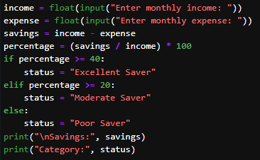
 | OUTPUT | 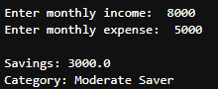
 | INTERPRETATION | This program asks the user for monthly income and monthly expense and computes savings.Using if–elif–else it categorises the data.

.
S.NO | BUSINESS REQUIREMENT | QUERY
4 | Expense List Processing with Loops  Given a list of expenses for 7 days, write a loop that:  Prints only expenses greater than 500  Counts how many such days exist  Prints their total and average | 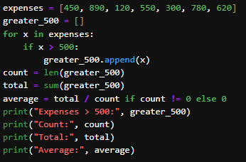
 | OUTPUT | 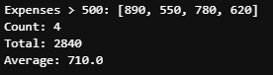
 | INTERPRETATION | Given a week’s list of expenses, the program loops through each value.  And print the expenses which are all above 500.

S.NO | BUSINESS REQUIREMENT | QUERY
5 | Function-Based Budget Advice  Write a function:  The function should return a recommendation:  If rent > 40% of income → "Reduce rent"  If food > 30% → "Control food spending"  If transport > 20% → “Transport cost high”  Else → “Good budget management | 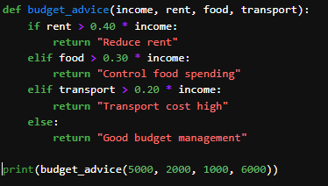
 | OUTPUT
 | INTERPRETATION | This task defines a function budget_advice() that accepts income, rent, food, and transport.  It compares each expense with standard budgeting percentages.

S.NO | BUSINESS REQUIREMENT | QUERY
6 | Track Recurring Expenses Using Tuples & Sets  Create two tuples:  Tuple A = recurring fixed expenses (rent, WiFi, subscriptions)  Tuple B = recurring variable expenses (food, travel, shopping)  Tasks:  Convert both to sets  Identify common items  Identify items unique to each category | 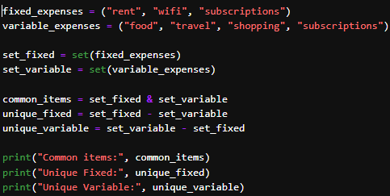
 | OUTPUT | 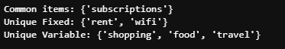
 | INTERPRETATION | This program stores fixed and variable expenses in tuples.It demonstrates tuple-to-set conversion and set operations.

S.NO | BUSINESS REQUIREMENT | QUERY
7 | Class-Based Financial Profile  Create a class FinanceProfile with attributes:  name  monthly_income  total_expense  Include methods:  calculate_savings()  spending_status() returning: “Saving”, “Balanced”, or “Overspending”  Create objects for 3 users and print their status | 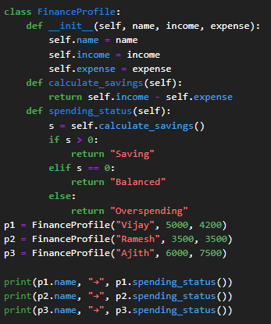
 | OUTPUT | 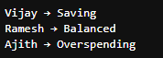
 | INTERPRETATION | This task introduces a class FinanceProfile.  Each object has attributes like name, income, and expense which it shows whether they are saving the amount or spending their amount.

S.NO | BUSINESS REQUIREMENT | QUERY
8 | File Handling: Save & Load Expense Logs  Write a program to:  Accept user expenses for 7 days  Save them to a file expenses.txt  Then load the file and print the total weekly expense  Add error handling for missing or unreadable files | 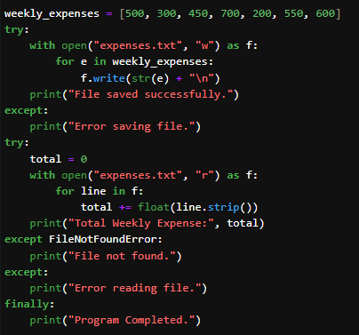
 | OUTPUT | 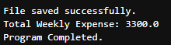
 | INTERPRETATION | First, weekly expenses are written to a file expenses.txt.Then, the file is read back and total weekly expense is calculated.try–except–finally handles errors safely.It shows how to store and retrieve data using files.

S.NO | BUSINESS REQUIREMENT | QUERY
9 | Create a Python class named ExpenseTracker that helps manage a user's personal finance details.  Create an object of this class and print:  Total Expense,Savings,Status | 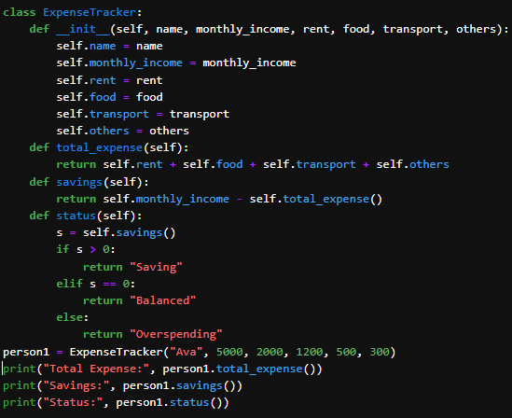
 | OUTPUT | 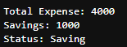
 | INTERPRETATION | This program shows the savings amount and status of savings.It shows How much amount did they are saving are whether they are overspending.

BU

S.NO | BUSINESS REQUIREMENT | QUERY
10 | Take monthly income and different expenses from the user  Calculate the total expense,Calculate savings  Display whether the user is Saving, Balanced, or Overspending  Use separate functions for:  Calculating total expense  Checking spending status | 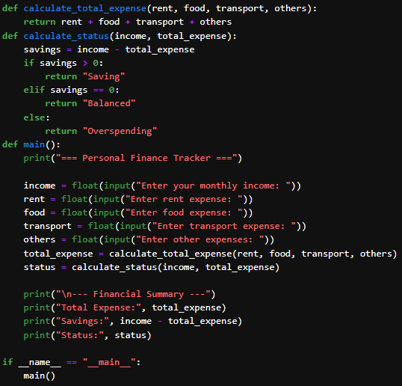
 | OUTPUT | 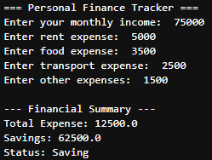
 | INTERPRETATION | It calculate the financial summary of the monthly expenses which we are spending.

3.2 ADVANTAGES OF THE SYSTEM

The Personal Finance Tracker project offers several practical benefits for users and students alike. It provides a simple and effective way to record, calculate, and analyze monthly expenses without requiring any manual effort. By automating financial calculations, the system helps users quickly understand whether they are saving, balancing their income, or overspending, thereby promoting better financial discipline and awareness. The project also makes excellent use of fundamental Python concepts such as functions, loops, conditional statements, file handling, and object-oriented programming, making it highly suitable for academic learning. Additionally, the modular design allows easy future enhancements such as adding graphical reports, databases, or a graphical user interface, making the project both practical and expandable.

SUMMARY :

This project titled “Finance Tracker” is designed to help individuals efficiently manage and analyze their monthly expenses using Python programming.
The system collects income and different categories of expenses such as food, rent, transport, and others from the user. It then calculates the total monthly expense and determines whether the user is saving, balanced, or overspending based on their financial status.
The project makes effective use of core Python concepts including functions, conditional statements, loops, file handling, and object-oriented programming to provide accurate financial insights.

CONCLUSION :

The Python Personal Finance Tracker project successfully demonstrates how simple programming concepts can be applied to solve real-life financial management problems. By automating the calculation of expenses, savings, and spending status, the system provides users with a clear understanding of their monthly financial behavior.The project effectively integrates core Python features such as functions, conditionals, loops, file handling, and object-oriented programming, making it a strong learning experience as well as a practical tool.Overall, this project highlights the importance of financial awareness and showcases Python’s capability in building meaningful, everyday applications.

